* Write a program to display “hello world” in C .

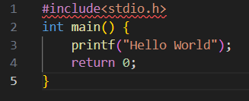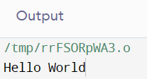 -> Output :

* Write a program to add two numbers (5&7) and display its sum .

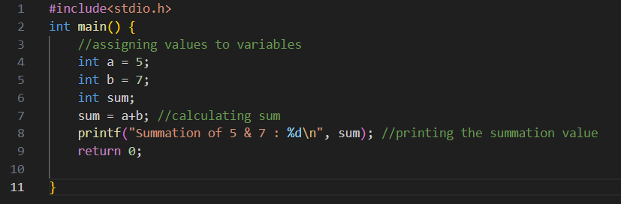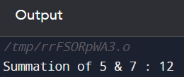-> Output :

* Write a program to multiply two numbers (10&8) and display its product .

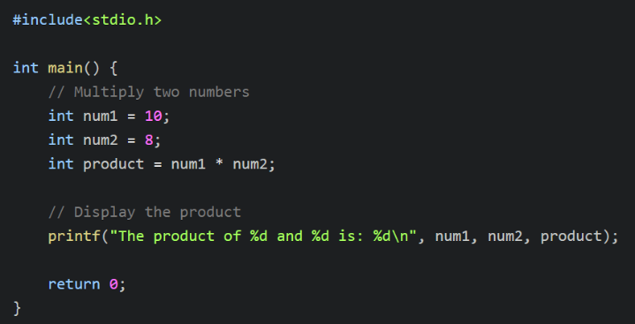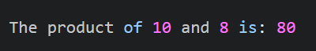-> Output :

* Write a program to calculate area of a circle having its radius (r=5).

-> Output :

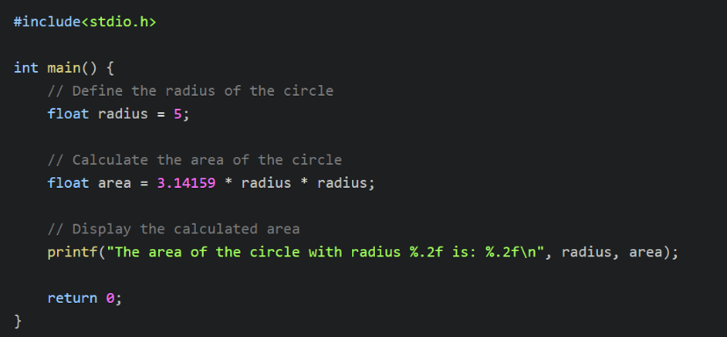

* Write a program to calculate area of an ellipse having its axes (minor=4cm, major=6cm).

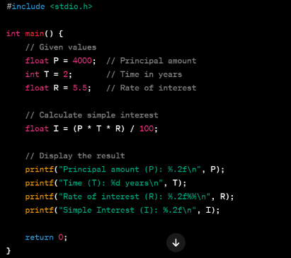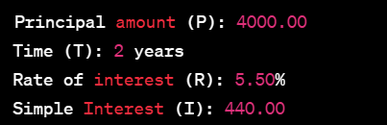 -> Output :

* Write a program to produce the output as shown below: x y expressions results 6 | 3 | x=y+3 | x=6 6 | 3 | x=y-2 | x=1 6 | 3 | x=y*5 | x=15 6 | 3 | x=x/y | x=2 6 | 3 | x=x%y | x=0 .

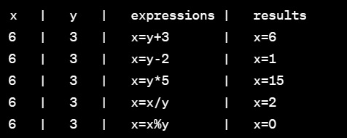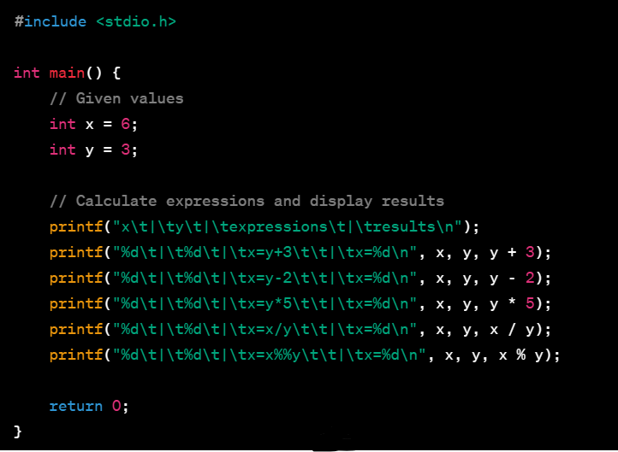 -> Output :

* Given x=3.0, y=12.5, z= 523.3, A=300.0, B=1200.5, C=5300.3, Write a program to display the following: X y z= 3.0| 12.5| 523.3| A B C= 300.0| 1200.5| 5300.3| --------------------------------------------------------------------- X y z= |3.00 |12.50 |523.30 A B C= |300.00 |1200.50 |52300.30

-> Output :

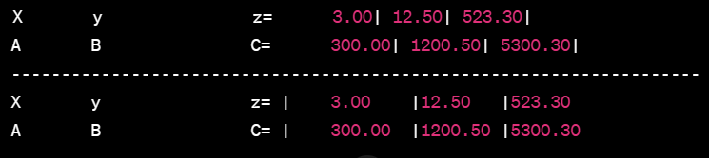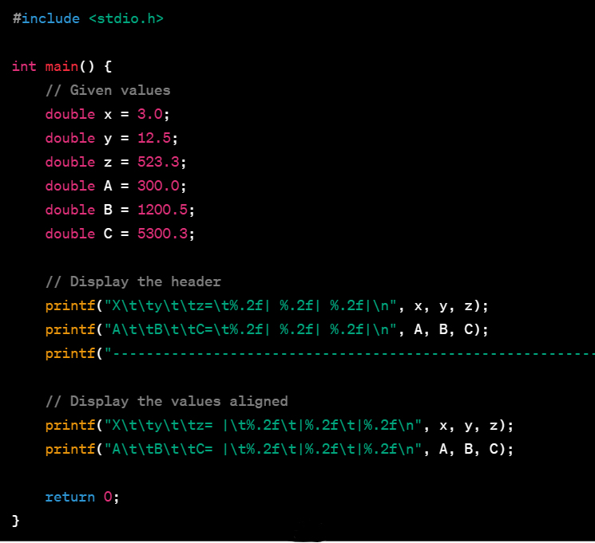

* Given the three numbers a(=8), b(=4),c and constant value PI=3.1415, calculate and display the following result using macros (preprocessor directives) a. c = PI * mult(a,b) //the macro mult(a,b) perform the multiplication of a & b(a*b) b. c= PI* sum(a,b) //the macro mult(a,b) perform the sum of a & b (a+b) c. c= PI *sub(a,b) //the macro mult(a,b) perform the subtraction of a & b (a-b)

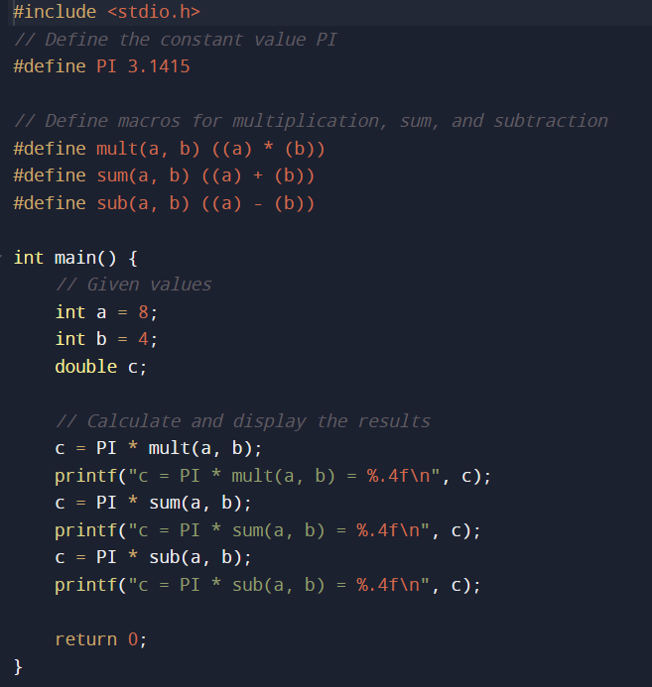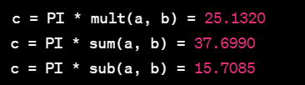-> Output :

* Demonstrate the differences among getch(), getche(), getchar(). Demonstrate the difference between scanf() & gets(), printf() & puts() .

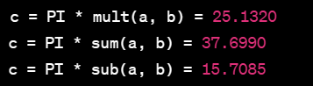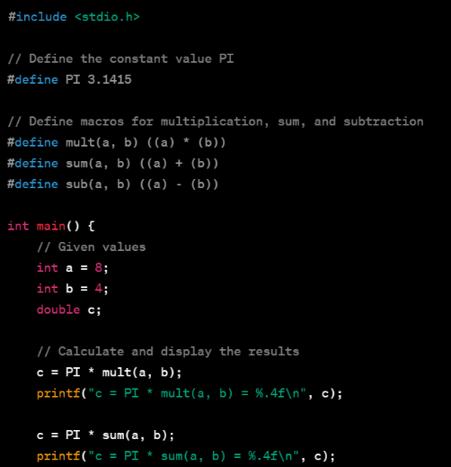 -> Output :

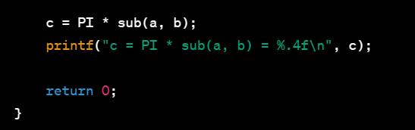

* Write a program to take a character input from keyboard and check if it is a number or alphabet or special character using ASCII CODE Again check if the character is using character functions below: a. Alphanumeric => isalnum() b. Blank character => isblank() c. Alphabetic => isalpha() d. Control character => iscntrl() e. Number-digit => isdigit() f. Upper case => isupper() g. Lower case => islower() h. Hexadecimal digit => ixdigit() i. Graphical character => isgraph() To evaluate area of triangle (sqrt(s(s-a)(s-b)(s-c ).

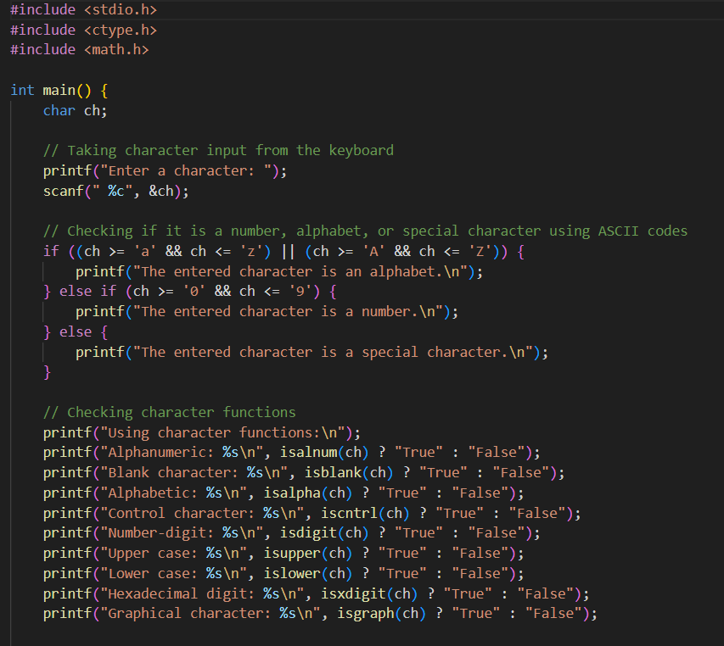-> output :

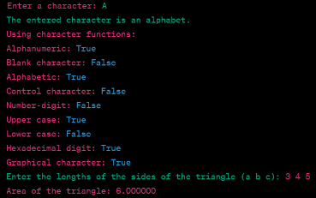

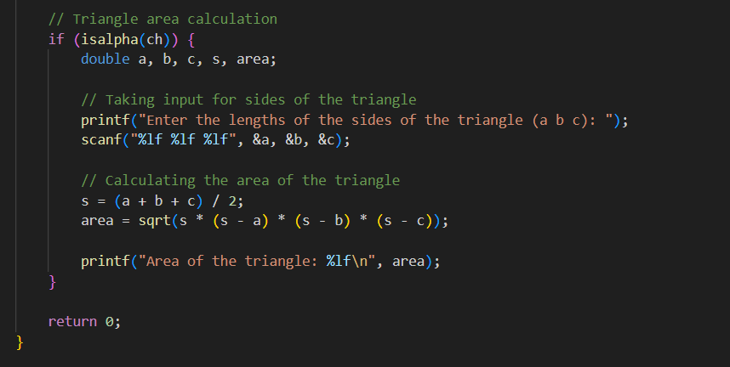

* Write a C program to find the area and volume of sphere. Formulas are:- Area = 4*PI*R*R Volume = 4/3*PI*R*R*R. Note : Assume PI=3.14 13. Write a C program to print the multiply value of two accepted numbers .
* **Program to find the area and volume of a sphere :**
* 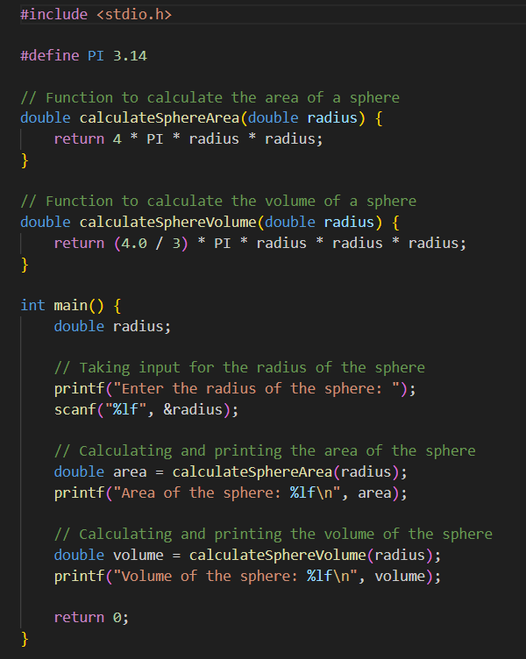 **Program to print the multiplication of two accepted numbers:**

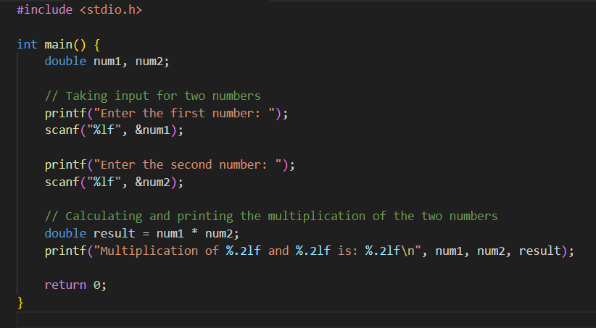

* Write a C program to convert centigrade into Fahrenheit. Formula: C= (F-32)/1.8.

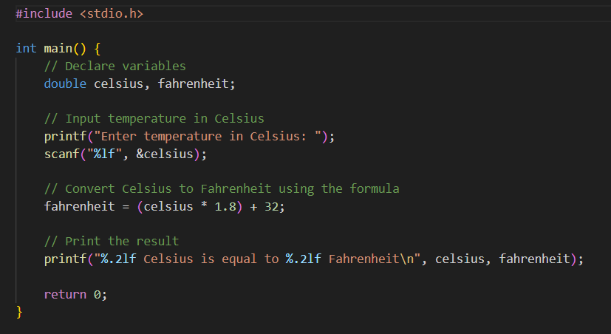-> Output :

* 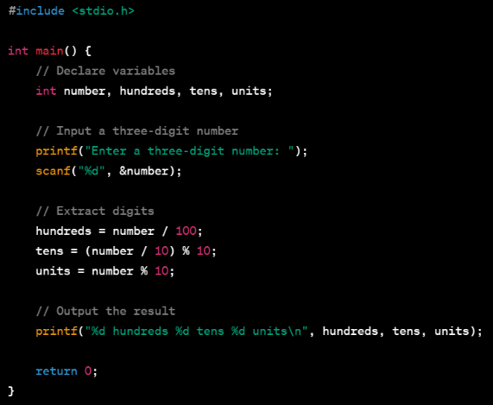Write a C program to read in a three digit number and produce the following output (assuming that the input is 347) 3 hundreds 4 tens 7 units

 -> Output :

* Write a C program to read in two integers and display one as a percentage of the other. Typically your output should look like 20 is 50.00% of 40 assuming that the input numbers were 20 and 40. Display the percentage correct to 2 decimal places.

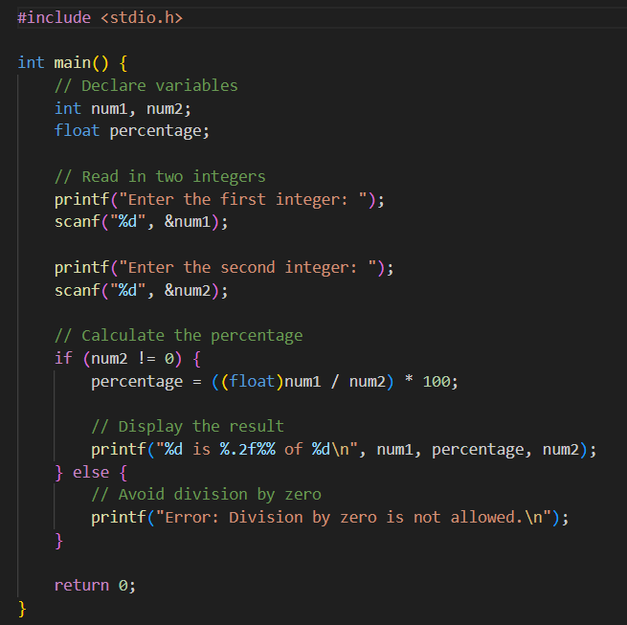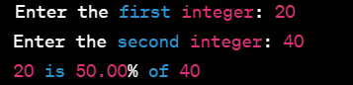-> Output :

* Write a C program to find out whether the character pressed through the keyboard is a digit or not (using conditional operator).

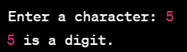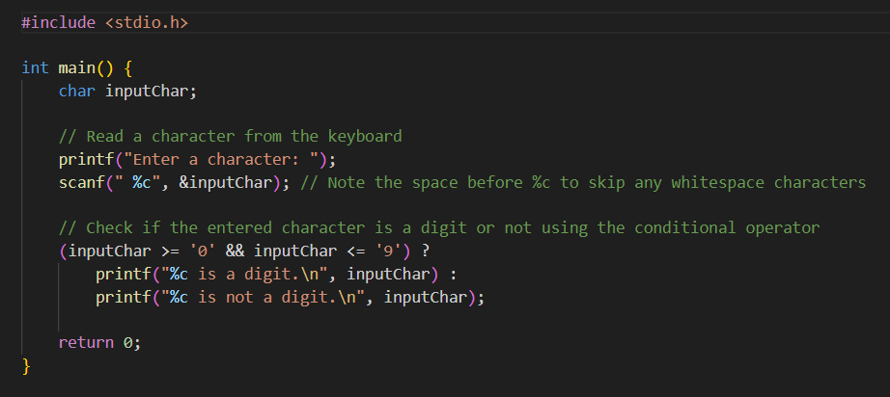->Output :

* Write a C program to swap variable values of i and j.

->Output :

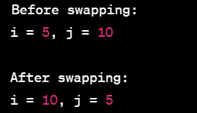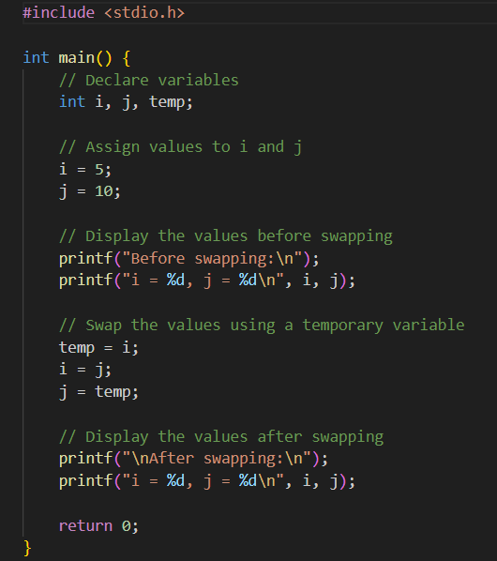

* Write a program to read a floating point number from keyboard and print its integer and fractional part separately.

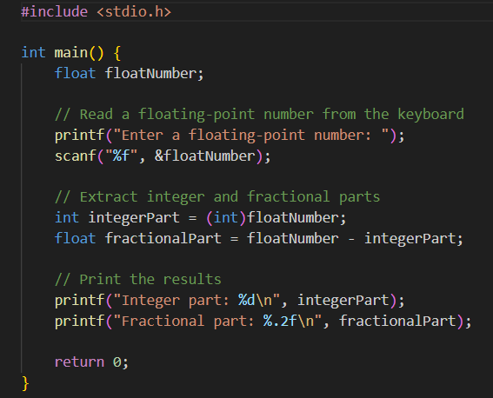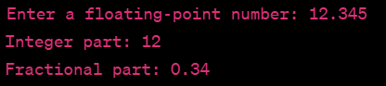-> Output :

* Write a program to read and print a character using getchar(), getch(), getche(), putchar(), putch().

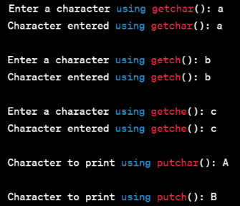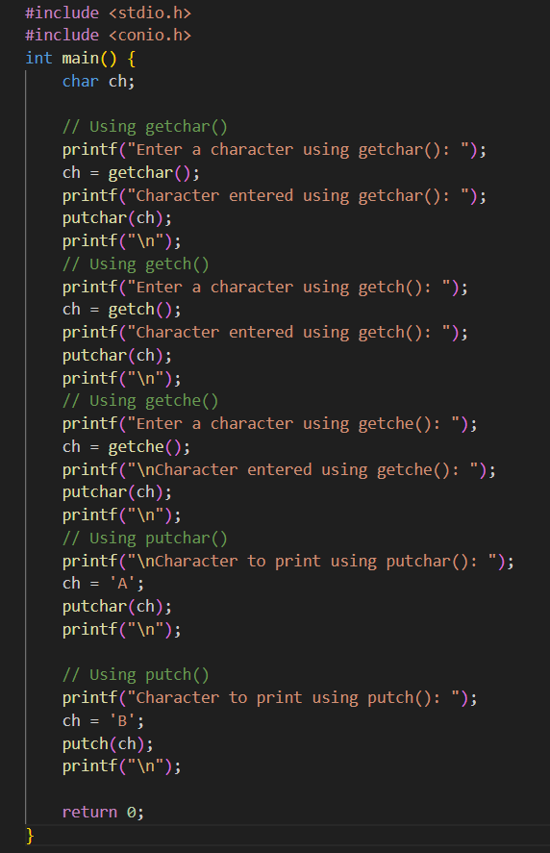

* Write a program to find the Simple Interest(Simple Interest,I=P*N*R/100) where P=Principal,N=no: of years, R= Rate of Interes

